* 1. Access <https://portal.azure.com/>, register an account if you don’t have one, then click **Start** in **Start with an Azure free trial** section.  
  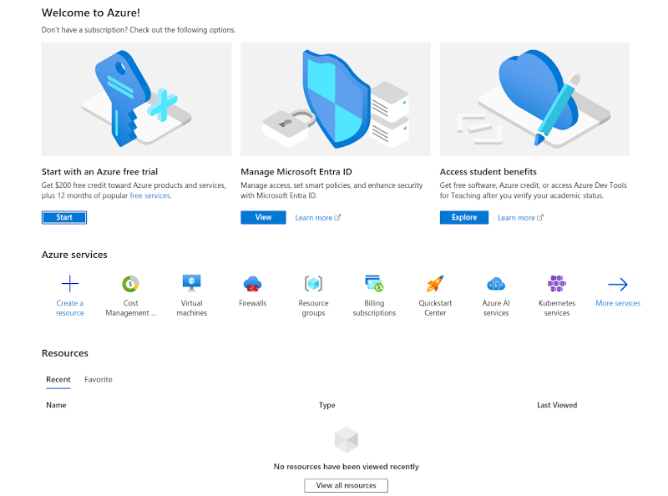
* 2. Click on **Start free  
  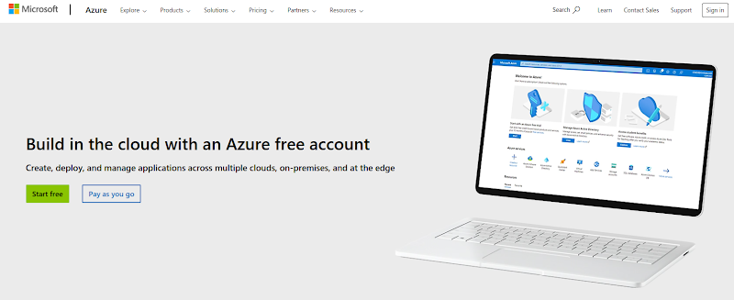**
* 3.After selecting your account to begin, you will be directed to a signup page to fill in more information, check the box **I agree to the customer agreement**, and press **Next.  
  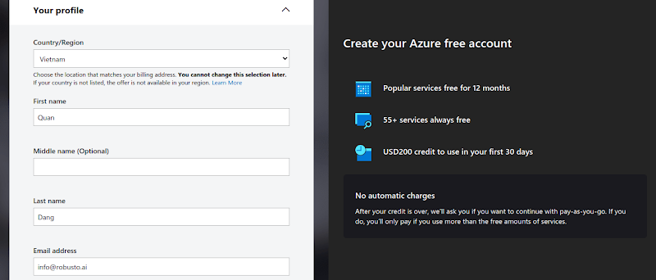**
* 4. Please proceed to enter your credit/debit card information now. **Please note that $1 will be deducted from your account for verification and then refunded, so please ensure that you have at least $1 in your account.  
  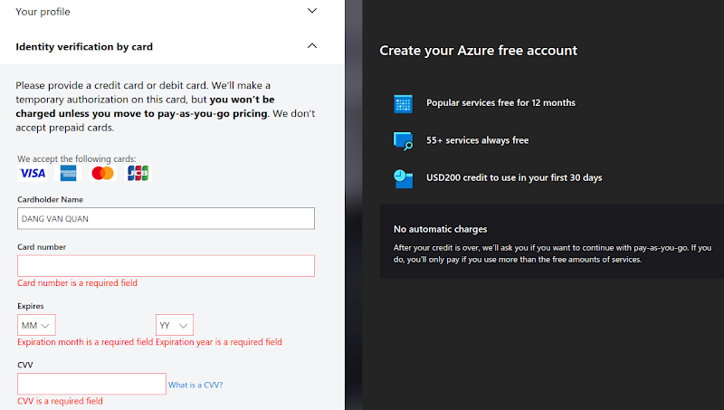**
* 5. Click **Next**. Azure will prompt you to sign in again before displaying **You're ready to start with Azure**.  
  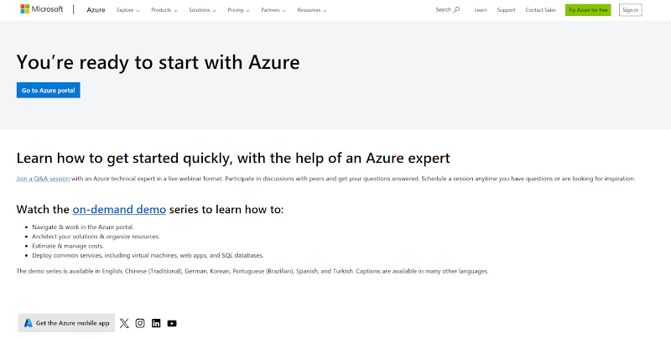
* 6. Go to the Azure portal at <https://portal.azure.com/>, and you should see the below image.  
  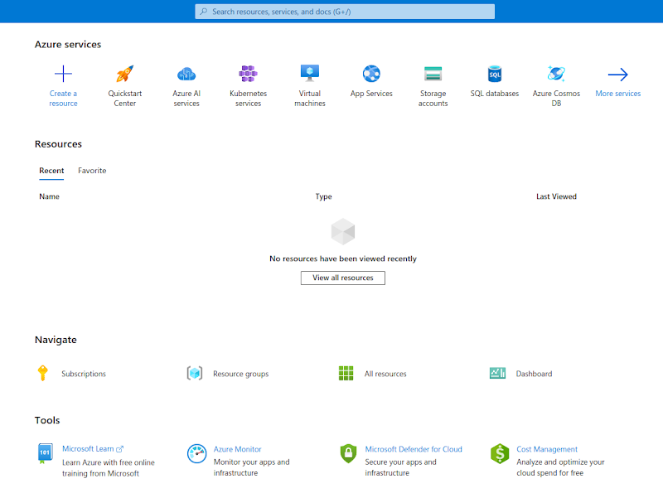
* 7. Similar to the guide Create a VM on GCP, you can create one on Azure.